|  |  |
| --- | --- |
| **Date** | **19/11/2022** |
| **Project Title** | **Smart Fashion Recommender Application** |
| **Team ID** | **PNT2022TMID50712** |

Index.html

<!DOCTYPEhtml>

<htmllang="en">

<head>

<metacarset="UTF-8">

<metahttp-equiv="X-UA-Compatible"content="IE=edge">

<metaname="viewport"content="width=device-width,initial-scale=1.0">

<title>RST/Home</title>

<linkrel="stylesheet"href="https://cdnjs.cloudflare.com/ajax/libs/font-awesome/4.7.0/css/font- awesome.min.css">

<linkrel="stylesheet"href="https://rakesh87.s3.us-east.cloud-object-storage.appdomain.cloud/style.css">

</head>

<body>

<sectionid="header">

<a href="#"><img src="https://saravanan2001mohan.s3.us-east.cloud-object-storage.appdomain.cloud/rst%20(1).png"class="logo"alt=""width="150"height="60"></a>

<div>

<ulid="navbar">

<li><aclass="active" href="index.html">Home</a></li>

<li><ahref="products.html">Products</a></li>

<li><ahref="blog.html">Blog</a></li>

<li><ahref="about.html">About</a></li>

<li><ahref="contact.html">Contact</a></li>

<li><ahref="cart.html"><iclass="fafa-shopping-bag"></i></a></li>

<li><ahref="register.html"><iclass="fafa-user-secret"></i></a></li>

</ul>

</section>

<sectionid="hero">

<h4>"HappinessDependsUponOurselves"</h4>

<h2>SmartFashionRecommender</h2>

<h1>Application</h1>

<p>DressUpInConfidence</p>

<buttonclass="normal">Shopnow</button>

</section>

<sectionid="feature"class="section-p1">

<divclass="fe-box">

<imgsrc="https://unik.s3.jp-tok.cloud-object-storage.appdomain.cloud/freeship.png"alt="" width="100"height="100">

<h6>FreeShipping</h6>

</div>

<divclass="fe-box">

<imgsrc="https://unik.s3.jp-tok.cloud-object-storage.appdomain.cloud/orderonline.jpg" alt=""width="100"height="100">

<h6>OnlineOrder</h6>

</div>

<divclass="fe-box">

<imgsrc="https://unik.s3.jp-tok.cloud-object-storage.appdomain.cloud/savemoney.jpg"alt="" width="100"height="100">

<h6>SaveMoney</h6>

</div>

<divclass="fe-box">

<imgsrc="https://unik.s3.jp-tok.cloud-object-storage.appdomain.cloud/promotion.jpg"alt="" width="100"height="100">

<h6>Promotions</h6>

</div>

<divclass="fe-box">

<imgsrc="https://unik.s3.jp-tok.cloud-object-storage.appdomain.cloud/happysell.jpg" alt=""width="100"height="100">

<h6>HappySell</h6>

</div>

<divclass="fe-box">

<imgsrc="https://unik.s3.jp-tok.cloud-object-storage.appdomain.cloud/support.jpg"alt=""width="100"height="100">

<h6>F24/7Support</h6>

</div>

</section>

<sectionid="product1"class="section-p1">

<h2>FeaturedProduct</h2>

<p>NewCollectionsNewModernDesigns</p>

<divclass="pro-container">

<divclass="pro">

<img src="https://unik.s3.jp-tok.cloud-object-storage.appdomain.cloud/shopshirt1.jpg"alt="">

<divclass="des">

<span>Attitude</span>

<h5>BluenBrownT-Shirts</h5>

<divclass="star">

<iclass="fafa-star"></i>

<iclass="fafa-star"></i>

<iclass="fafa-star"></i>

<iclass="fafa-star"></i>

<iclass="fafa-star"></i>

</div>

<h4>₹1500</h4>

</div>

<ahref="#"><iclass="fafa-shopping-bagbag"></i></a>

</div>

<divclass="pro">

<imgsrc="https://unik.s3.jp-tok.cloud-object-storage.appdomain.cloud/shopshirt2.jpg"alt="">

<divclass="des">

<span>U.S.PoloAssnn</span>

<h5>BluestripT-Shirts</h5>

<divclass="star">

<iclass="fafa-star"></i>

<iclass="fafa-star"></i>

<iclass="fafa-star"></i>

<iclass="fafa-star"></i>

<iclass="fafa-star"></i>

</div>

<h4>₹1570</h4>

</div>

<ahref="#"><iclass="fafa-shopping-bagbag"></i></a>

</div>

<divclass="pro">

<imgsrc="https://unik.s3.jp-tok.cloud-object-storage.appdomain.cloud/shopshirt3.jpg"

alt="">

<divclass="des">

<span>Zara</span>

<h5>PlainT-Shirts</h5>

<divclass="star">

<iclass="fafa-star"></i>

<iclass="fafa-star"></i>

<iclass="fafa-star"></i>

<iclass="fafa-star"></i>

<iclass="fafa-star"></i>

</div>

<h4>₹1400</h4>

</div>

<ahref="#"><iclass="fafa-shopping-bagbag"></i></a>

</div>

<divclass="pro">

<imgsrc="https://unik.s3.jp-tok.cloud-object-storage.appdomain.cloud/home5.jpg"alt="">

<divclass="des">

<span>Ruralking</span>

<h5>CheckedT-Shirts</h5>

<divclass="star">

<iclass="fafa-star"></i>

<iclass="fafa-star"></i>

<iclass="fafa-star"></i>

<iclass="fafa-star"></i>

<iclass="fafa-star"></i>

</div>

<h4>₹2000</h4>

</div>

<ahref="#"><iclass="fafa-shopping-bagbag"></i></a>

</div>

<divclass="pro">

<imgsrc="https://s3.jp-tok.cloud-object-storage.appdomain.cloud/unik/saree.jpg" alt="">

<divclass="des">

<span>Banarasi</span>

<h5>GeorgetteBandhani RamaBlue&OliveGreenSaree</h5>

<divclass="star">

<iclass="fafa-star"></i>

<iclass="fafa-star"></i>

<iclass="fafa-star"></i>

<iclass="fafa-star"></i>

<iclass="fafa-star"></i>

</div>

<h4>₹10,000</h4>

</div>

<ahref="#"><iclass="fafa-shopping-bagbag"></i></a>

</div>

<divclass="pro">

<imgsrc="https://s3.jp-tok.cloud-object-storage.appdomain.cloud/unik/saree1.jpg"alt="">

<divclass="des">

<span>Banarasi</span>

<h5>BanarasiSilkJaalDarkMaroonSaree</h5>

<divclass="star">

<iclass="fafa-star"></i>

<iclass="fafa-star"></i>

<iclass="fafa-star"></i>

<iclass="fafa-star"></i>

<iclass="fafa-star"></i>

</div>

<h4>₹9000</h4>

</div>

<ahref="#"><iclass="fafa-shopping-bagbag"></i></a>

</div>

<divclass="pro">

<imgsrc="https://s3.jp-tok.cloud-object-storage.appdomain.cloud/unik/saree2.jpg"alt="">

<divclass="des">

<span>Banarasi</span>

<h5>BanarasiSilkButtisYellowSaree</h5><br>

<divclass="star">

<iclass="fafa-star"></i>

<iclass="fafa-star"></i>

<iclass="fafa-star"></i>

<iclass="fafa-star"></i>

<iclass="fafa-star"></i>

</div>

<h4>₹8000</h4>

</div>

<ahref="#"><iclass="fafa-shopping-bagbag"></i></a>

</div>

<divclass="pro">

<imgsrc="https://s3.jp-tok.cloud-object-storage.appdomain.cloud/unik/saree3.jpg" alt="">

<divclass="des">

<span>Banarasi</span>

<h5>BanarasiSilkJaalPurpleSaree</h5><br>

<divclass="star">

<iclass="fafa-star"></i>

<iclass="fafa-star"></i>

<iclass="fafa-star"></i>

<iclass="fafa-star"></i>

<iclass="fafa-star"></i>

</div>

<h4>₹6000</h4>

</div>

<ahref="#"><iclass="fafa-shopping-bagbag"></i></a>

</div>

</div>

</section>

<sectionid="banner"class="section-m1">

<h4>RepairServices</h4>

<h2>Upto<span>70%off</span>Allt-Shirts&Accessories</h2>

<ahref="products.html"><buttonclass="normal">ExploreMore</button></a>

</section>

<sectionid="product1"class="section-p1">

<h2>NewArrivals</h2>

<p>Brandedshoe'sandT-shirts</p>

<divclass="pro-container">

<divclass="pro">

<imgsrc="https://s3.jp-tok.cloud-object-storage.appdomain.cloud/unik/shoe.jpg"height="400"alt="">

<divclass="des">

<span>adidas</span>

<h5>BlueShoe</h5>

<divclass="star">

<iclass="fafa-star"></i>

<iclass="fafa-star"></i>

<iclass="fafa-star"></i>

<iclass="fafa-star"></i>

<iclass="fafa-star"></i>

</div>

<h4>₹6000</h4>

</div>

<ahref="#"><iclass="fafa-shopping-bagbag"></i></a>

</div>

<divclass="pro">

<imgsrc="https://s3.jp-tok.cloud-object-storage.appdomain.cloud/unik/shoe1.jpg"height="400"alt="">

<divclass="des">

<span>Bata</span>

<h5>Brownleathershoe</h5>

<divclass="star">

<iclass="fafa-star"></i>

<iclass="fafa-star"></i>

<iclass="fafa-star"></i>

<iclass="fafa-star"></i>

<iclass="fafa-star"></i>

</div>

<h4>₹8000</h4>

</div>

<ahref="#"><iclass="fafa-shopping-bagbag"></i></a>

</div>

<divclass="pro">

<imgsrc="https://s3.jp-tok.cloud-object-storage.appdomain.cloud/unik/shoe2.jpg"height="400"alt="">

<divclass="des">

<span>Nike</span>

<h5>SandleHighHeel</h5>

<divclass="star">

<iclass="fafa-star"></i>

<iclass="fafa-star"></i>

<iclass="fafa-star"></i>

<iclass="fafa-star"></i>

<iclass="fafa-star"></i>

</div>

<h4>₹6600</h4>

</div>

<ahref="#"><iclass="fafa-shopping-bagbag"></i></a>

</div>

<divclass="pro">

<imgsrc="https://s3.jp-tok.cloud-object-storage.appdomain.cloud/unik/shoe3.jpg"height="400"alt="">

<divclass="des">

<span>Walkaroo</span>

<h5>BrownHighHeel</h5>

<divclass="star">

<iclass="fafa-star"></i>

<iclass="fafa-star"></i>

<iclass="fafa-star"></i>

<iclass="fafa-star"></i>

<iclass="fafa-star"></i>

</div>

<h4>₹7800</h4>

</div>

<ahref="#"><iclass="fafa-shopping-bagbag"></i></a>

</div>

<divclass="pro">

<imgsrc="https://s3.jp-tok.cloud-object-storage.appdomain.cloud/unik/tops.jpg" alt="">

<divclass="des">

<span>Zara</span>

<h5>BlackSmileT-Shirts</h5>

<divclass="star">

<iclass="fafa-star"></i>

<iclass="fafa-star"></i>

<iclass="fafa-star"></i>

<iclass="fafa-star"></i>

<iclass="fafa-star"></i>

</div>

<h4>₹900</h4>

</div>

<ahref="#"><iclass="fafa-shopping-bagbag"></i></a>

</div>

<divclass="pro">

<imgsrc="https://s3.jp-tok.cloud-object-storage.appdomain.cloud/unik/tops1.jpg" alt="">

<divclass="des">

<span>Zara</span>

<h5>PinkdogT-Shirts</h5>

<divclass="star">

<iclass="fafa-star"></i>

<iclass="fafa-star"></i>

<iclass="fafa-star"></i>

<iclass="fafa-star"></i>

<iclass="fafa-star"></i>

</div>

<h4>₹900</h4>

</div>

<ahref="#"><iclass="fafa-shopping-bagbag"></i></a>

</div>

<divclass="pro">

<imgsrc="https://s3.jp-tok.cloud-object-storage.appdomain.cloud/unik/tops2.jpg" alt="">

<divclass="des">

<span>Zara</span>

<h5>BlackandWhiteTrendyShirt</h5>

<divclass="star">

<iclass="fafa-star"></i>

<iclass="fafa-star"></i>

<iclass="fafa-star"></i>

<iclass="fafa-star"></i>

<iclass="fafa-star"></i>

</div>

<h4>₹1500</h4>

</div>

<ahref="#"><iclass="fafa-shopping-bagbag"></i></a>

</div>

<divclass="pro">

<imgsrc="https://s3.jp-tok.cloud-object-storage.appdomain.cloud/unik/tops3.jpg" alt="">

<divclass="des">

<span>Zara</span>

<h5>GreenPandaShirt</h5>

<divclass="star">

<iclass="fafa-star"></i>

<iclass="fafa-star"></i>

<iclass="fafa-star"></i>

<iclass="fafa-star"></i>

<iclass="fafa-star"></i>

</div>

<h4>₹600</h4>

</div>

<ahref="#"><iclass="fafa-shopping-bagbag"></i></a>

</div>

</div>

</section>

<sectionid="sm-banner"class="section-p1">

<divclass="banner-box">

<h4>CrazyDeals</h4>

<h2>Buy1get1free</h2>

<span>ThebestclassicdressisonsaleatUNik</span>

<ahref="products.html"><buttonclass="white">LearnMore</button></a>

</div>

<divclass="banner-boxbanner-box2">

<h4>spring/summer</h4>

<h2>upcommigseasons</h2>

<span>ThebestclassicdressisonsaleatUNik</span>

<ahref="blog.html"><buttonclass="white">Collection</button></a>

</div>

</section>

<sectionid="banner3">

<divclass="banner-box">

<h2>SEASONALSALE</h2>

<h3>Wintercollection50%off</h3>

</div >

<divclass="banner-boxbanner-box2">

<h2>SEASONALSALE</h2>

<h3>Wintercollection50%off</h3>

</div>

<divclass="banner-boxbanner-box3">

<h2>SEASONALSALE</h2>

<h3>Wintercollection50%off</h3>

</div>

</section>

<sectionid="newsletter"class="section-p1">

<divclass="newstext">

<h4>SignupforNewsLetters</h4>

<p>GetEmailupdatesaboutourlatestshopand<span>specialoffer</span>

</p>

</div>

<divclass="form">

<inputtype="text"placeholder="YourE-mailAddress">

<buttonclass="normal">SignUp</button>

</div>

</section>

<footerclass="section-p1">

<divclass="col">

<img class="logo" src="https://saravanan2001mohan.s3.us-east.cloud-object-storage.appdomain.cloud/rst%20(1).png"alt=""width="200"height="100">

<h4>Contact</h4>

<p><strong>E-Mail:</strong[>rstsmartfashion@gmail.com](mailto:rstsmartfashion@gmail.com)</p>

<p><strong>Phone:</strong>1234567890</p>

<divclass="follow">

<h4>Followus</h4>

<divclass="icon">

<iclass="fafa-facebook-f"></i>

<iclass="fafa-twitter"></i>

<iclass="fafa-instagram"></i>

<iclass="fafa-pinterest-p"></i>

<iclass="fafa-youtube"></i>

</div>

</div>

</div>

<divclass="col">

<h4>About</h4>

<ahref="#">Aboutus</a>

<ahref="#">DeliveryInformation</a>

<ahref="#">PrivacyPolicy</a>

<ahref="#">Tearms&Conditions</a>

<ahref="#">Contactus</a>

</div>

<divclass="col">

<h4>MyAccount</h4>

<ahref="#">SignIn</a>

<ahref="#">ViewCart</a>

<ahref="#">MyWishlist</a>

<ahref="#">Trackmyorder</a>

<ahref="#">Help</a>

</div>

</footer>

<divclass="copyright">

<center><p>©2022,PNT2022TMI36870-SmartFashionRecommenderApplication

</p></center>

</div>

<scriptsrc="script.js"></script>

</body>

</html>

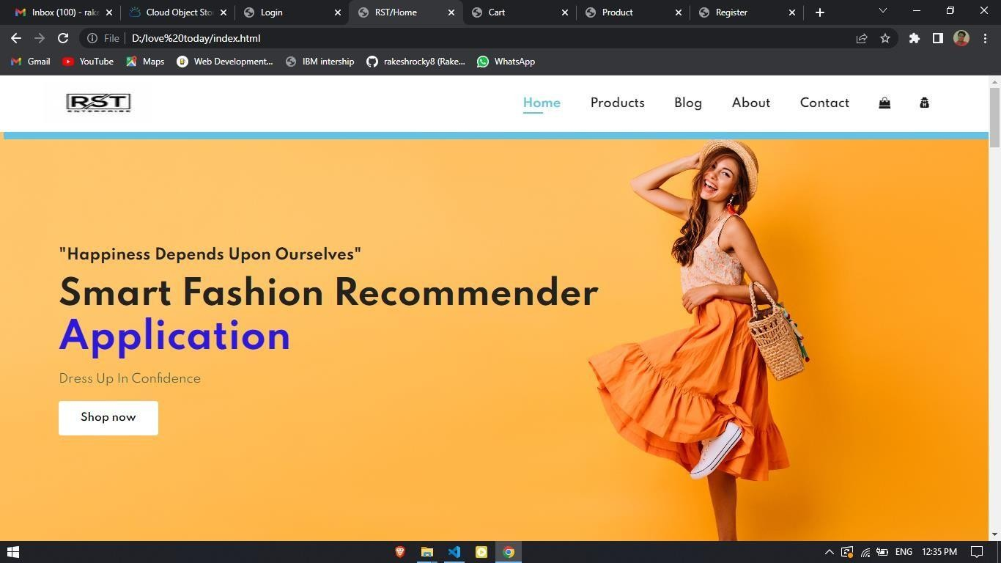

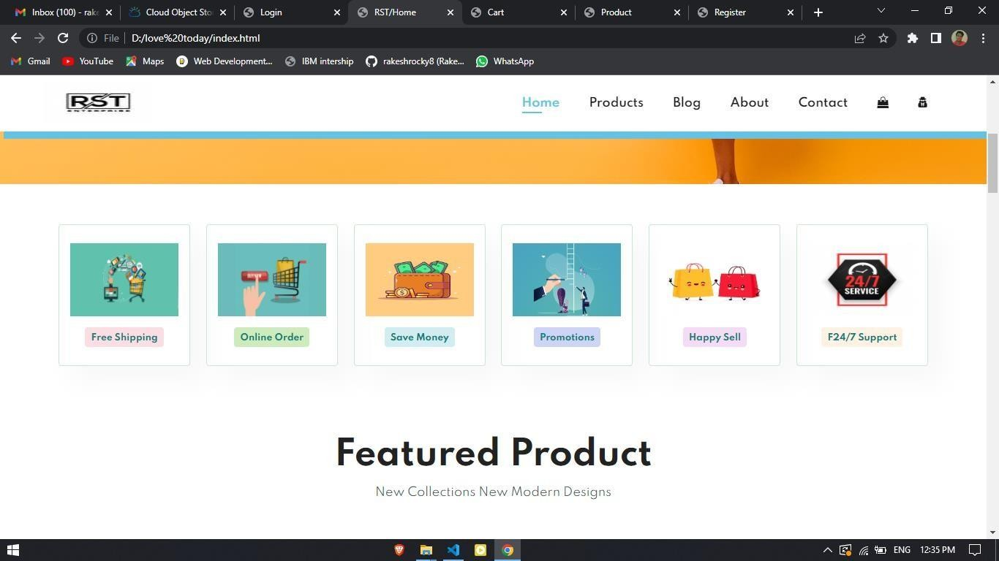

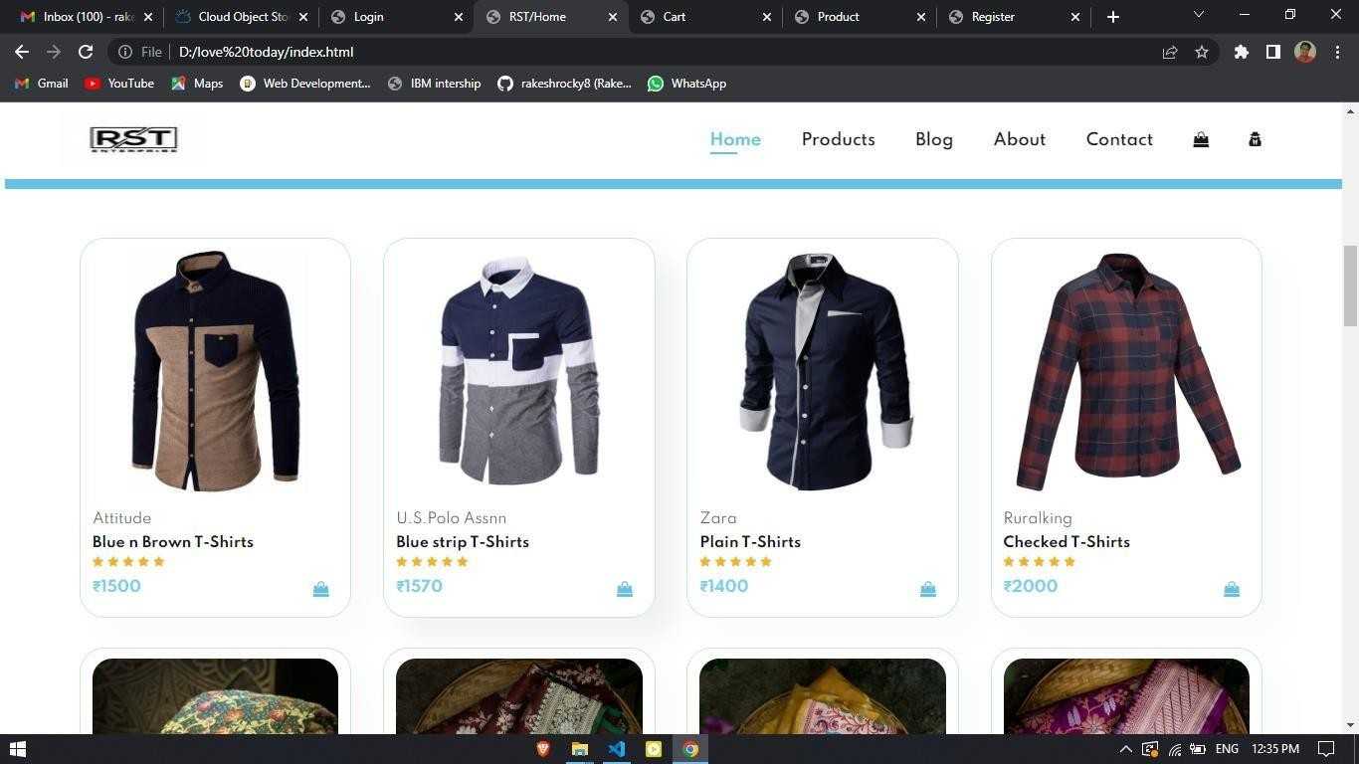

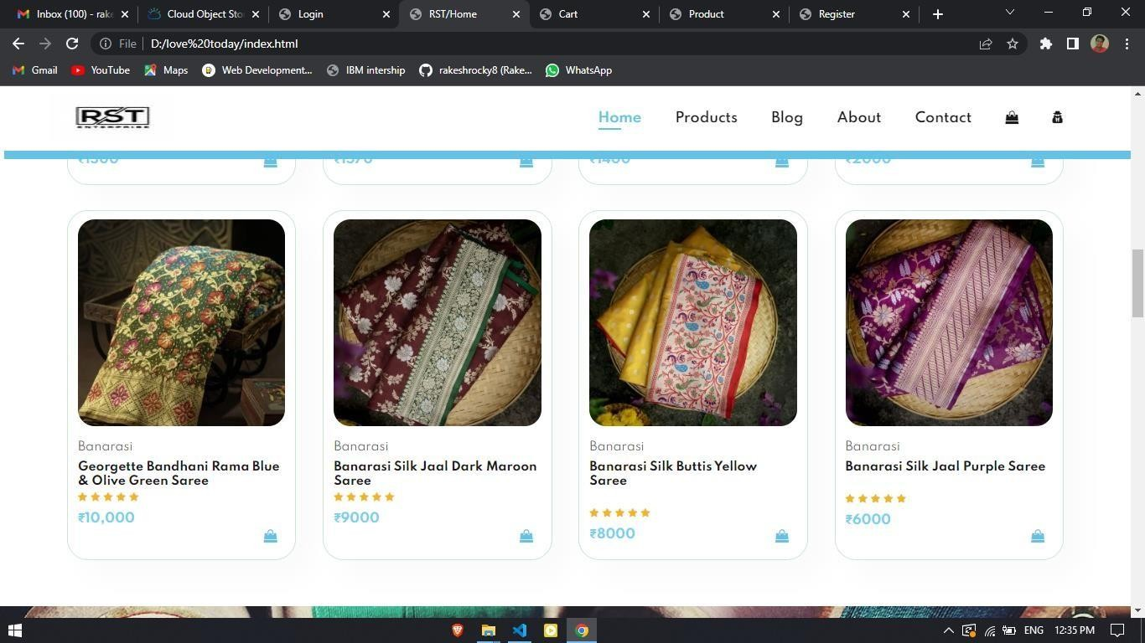

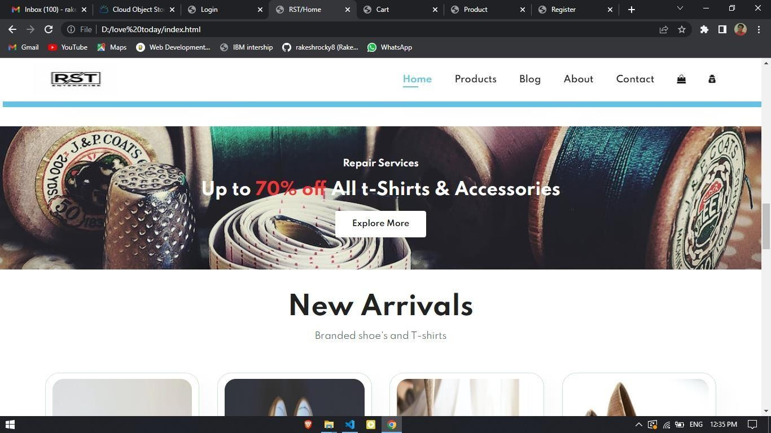

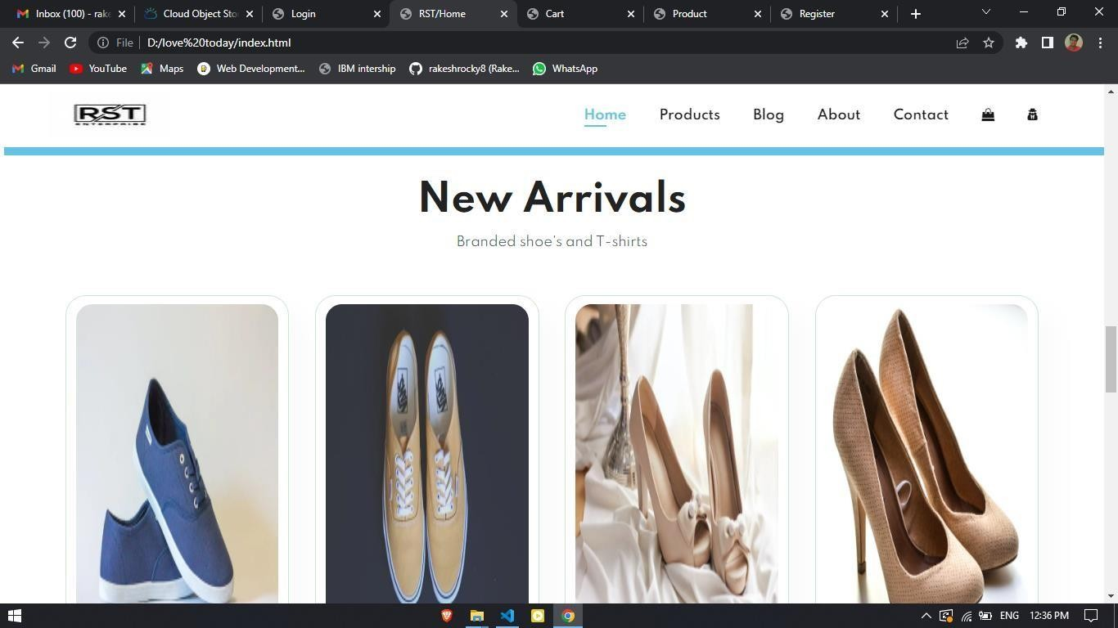

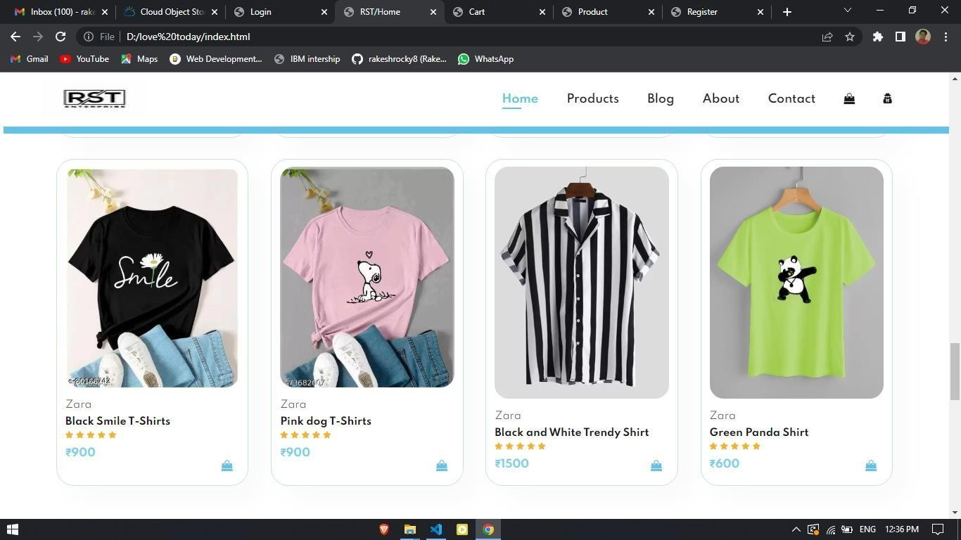

CreatingUIforAdminPanelAdminLogin

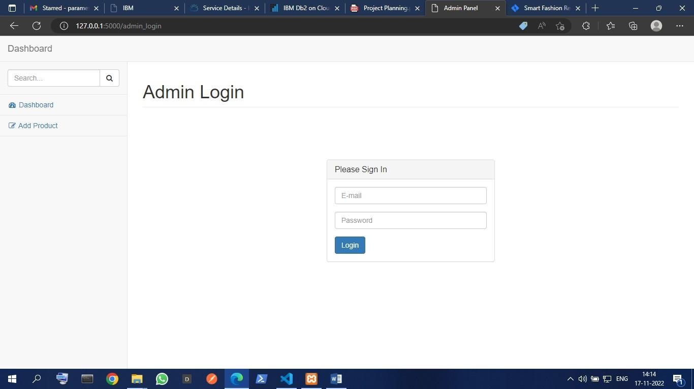

AdminPanel

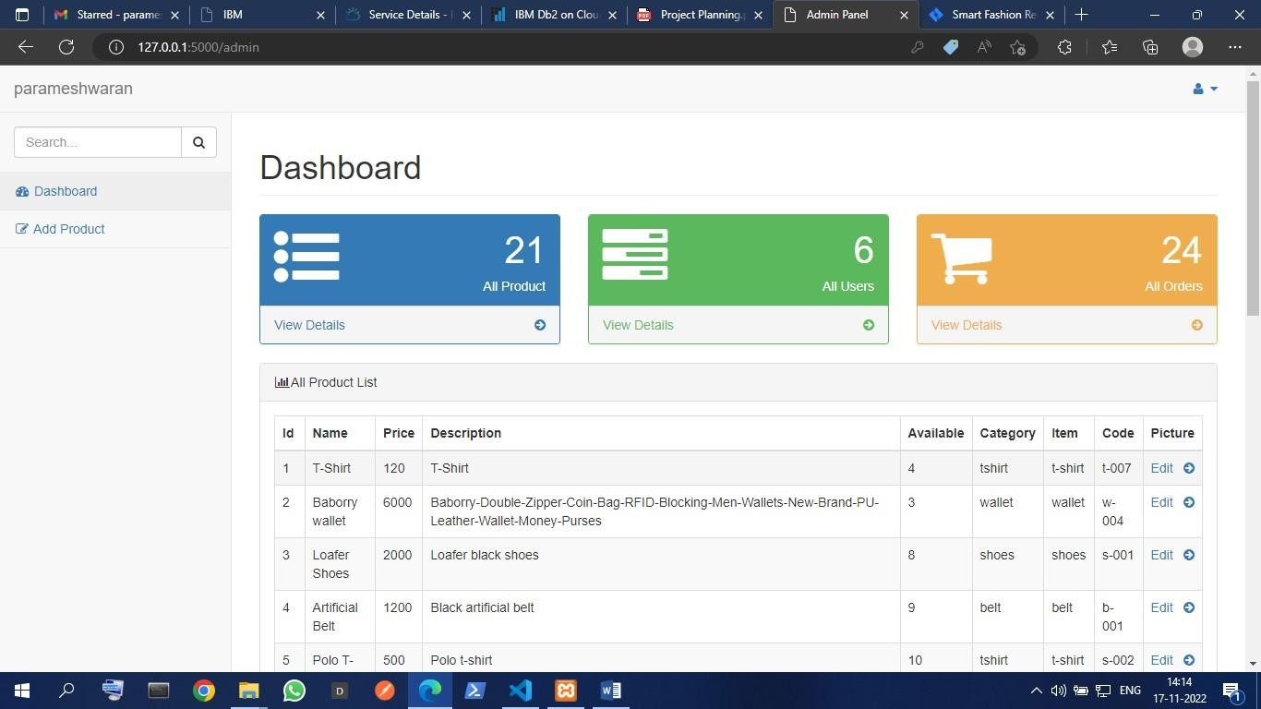

Creatingdatabaseconnectionforadminpanel

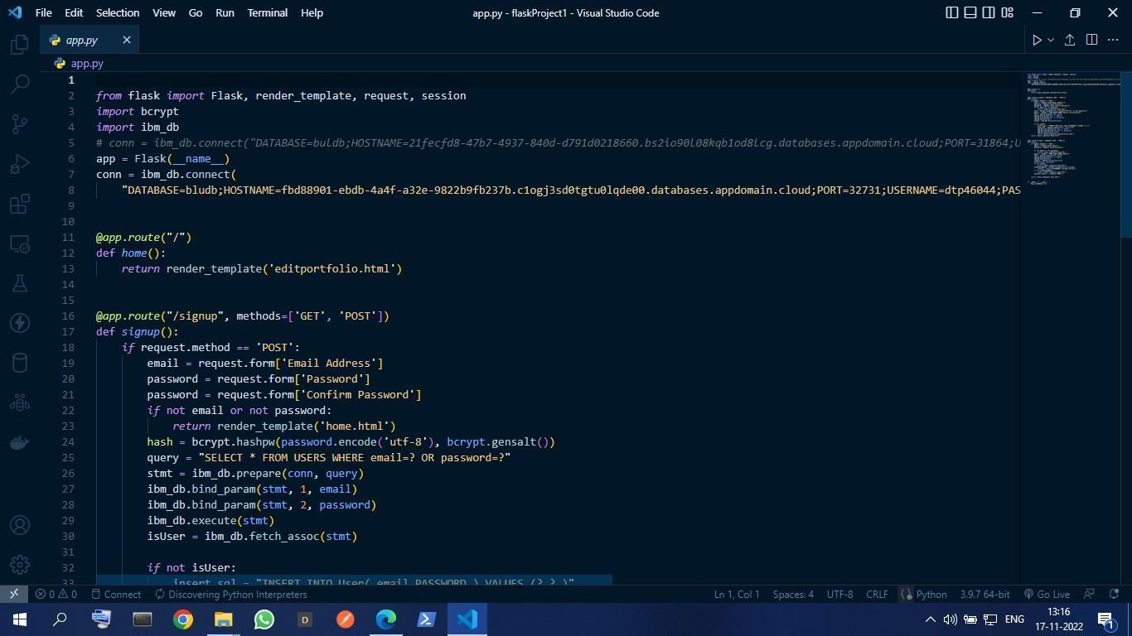

CompletingtheAdminpanelAddProduct

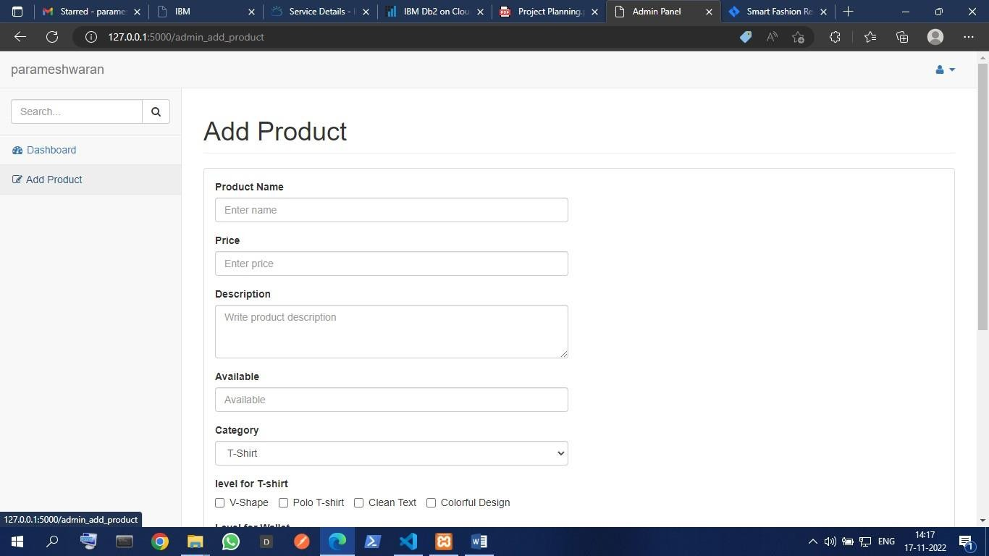

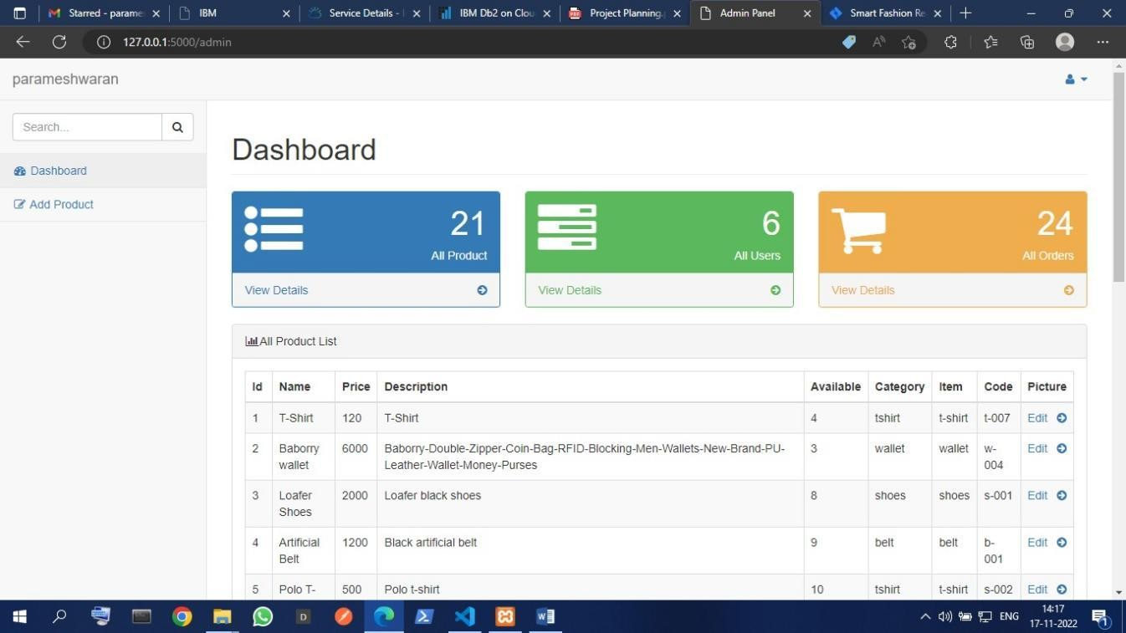Dashboard

CreatingChatBotforapplication

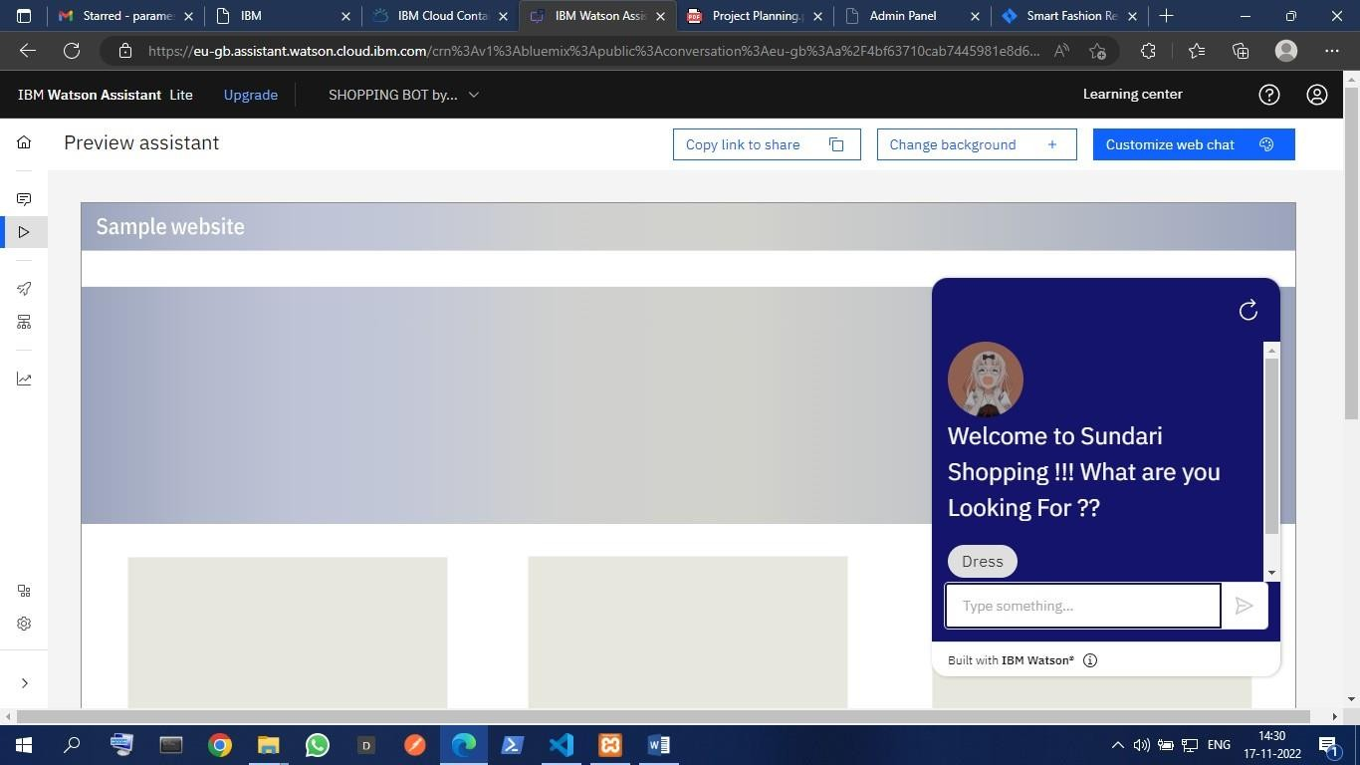

AddingFeaturesofChatBot

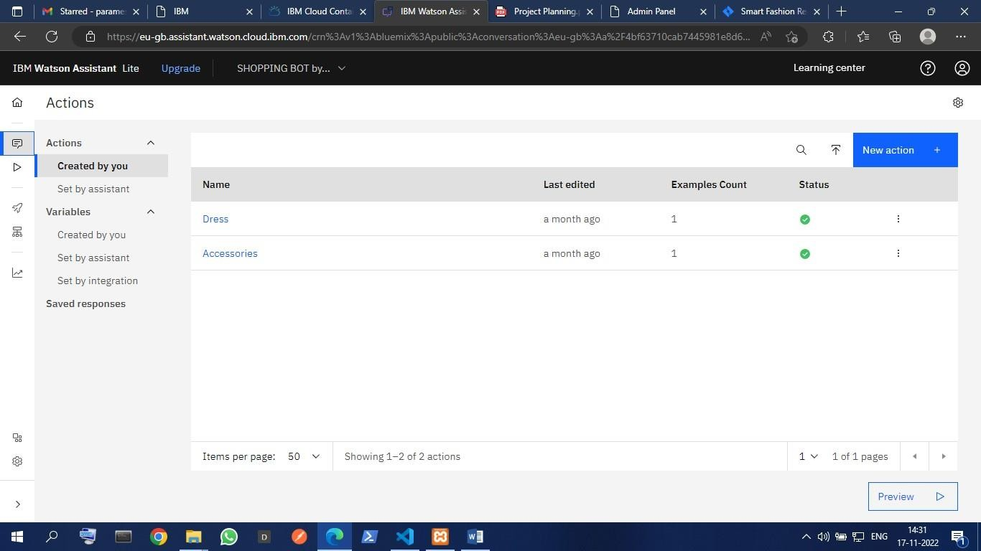

IntegrateChatBotwithWebsite

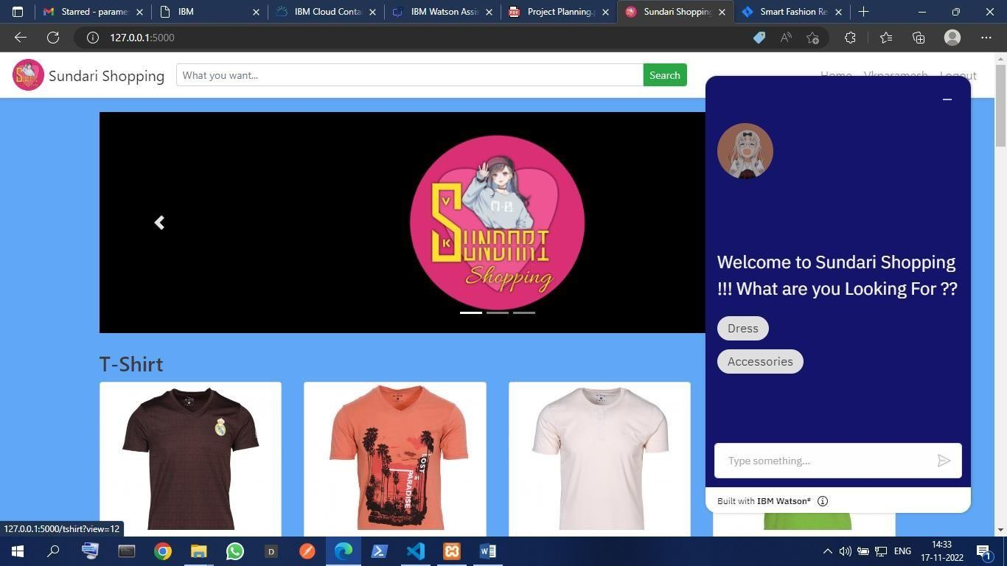

CompletingChatBot

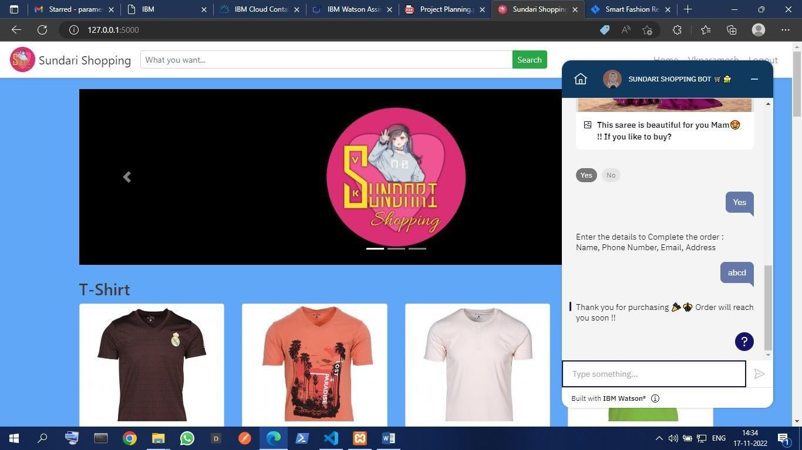

Deploy the applicationUserRegisterPage:-

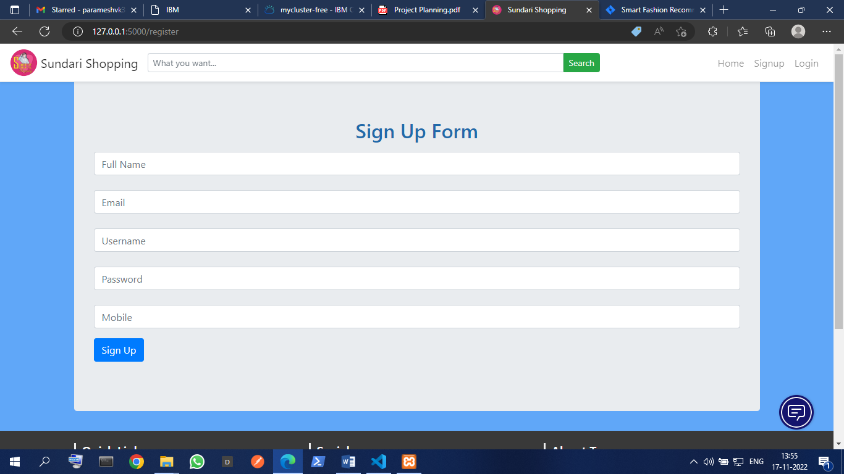

UserLoginPage :-

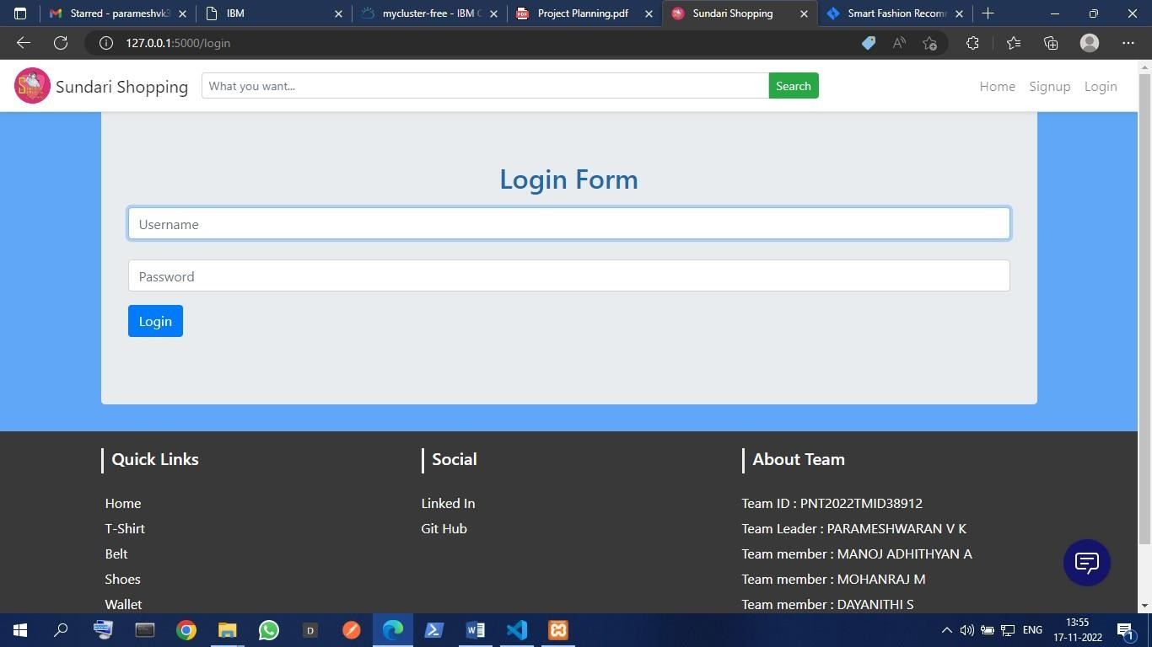

HomeScreen:-

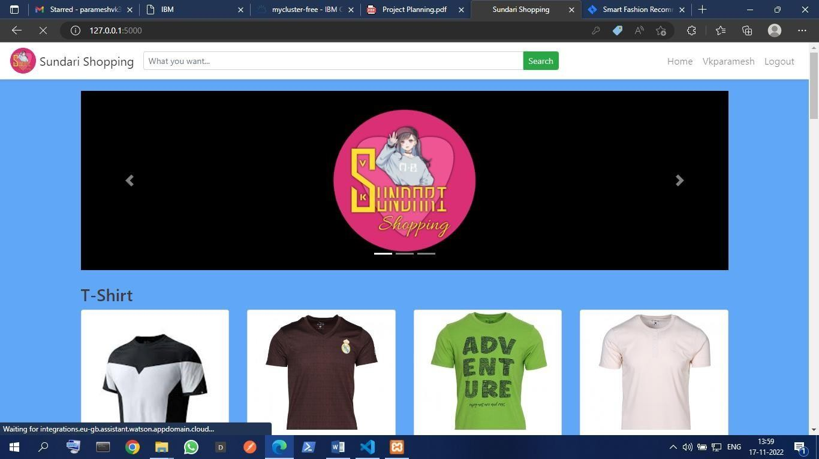

ProductPage:-

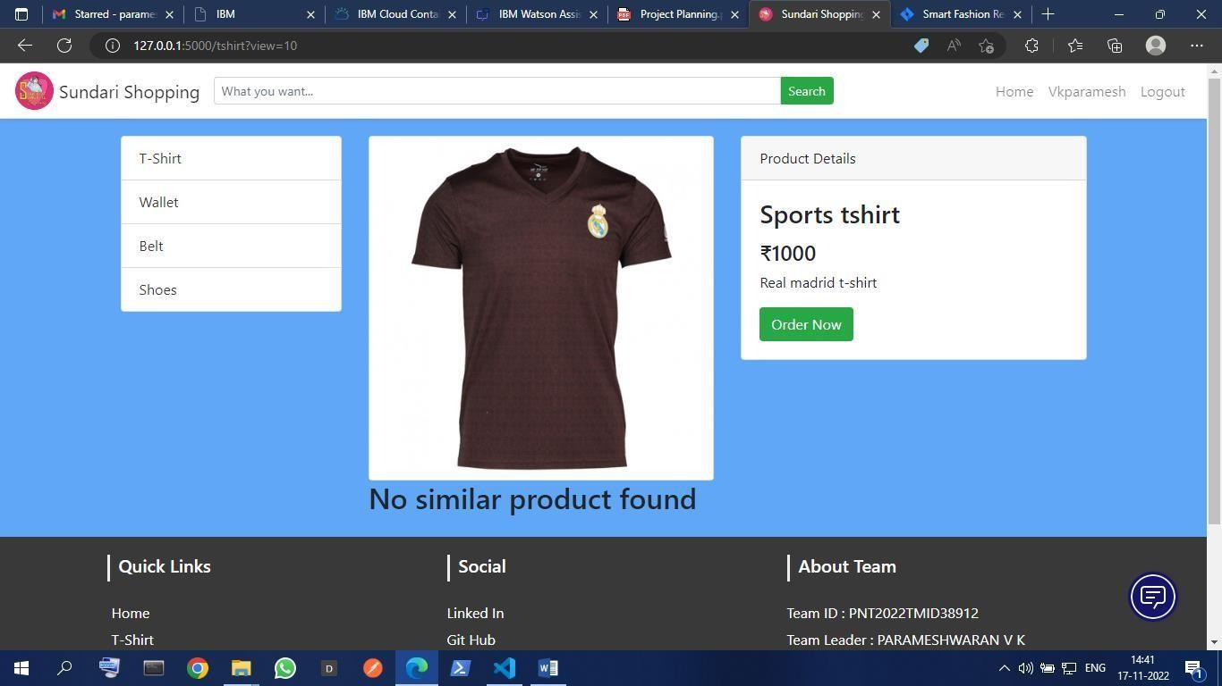

AdminLogin:-

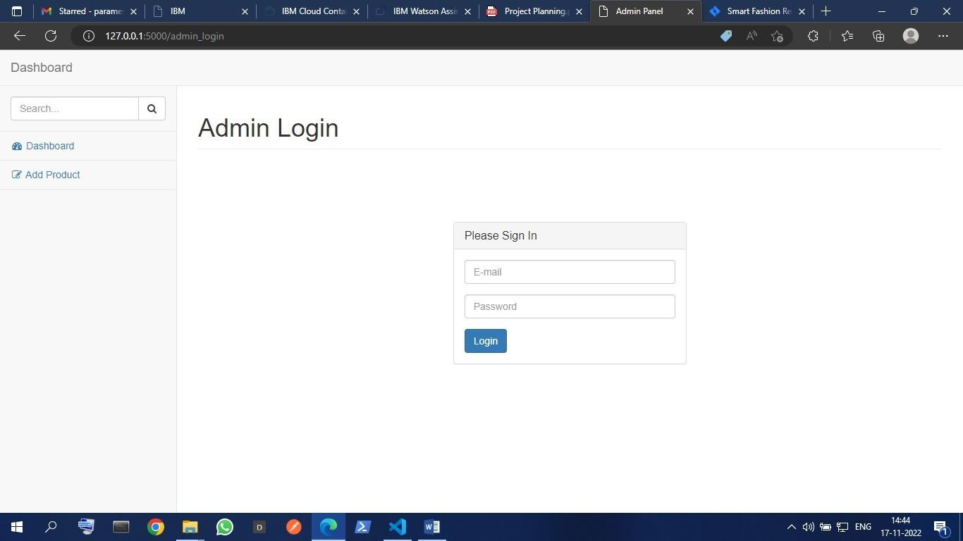

**AdminDashboard:-**

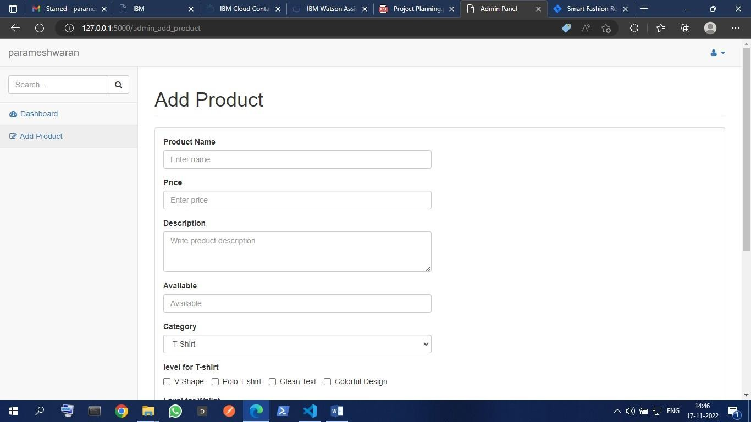

**ChatBot:-**

